Technical Assessment

Deploying Rocket.Chat Server – Installing in my own server.

I chose to create a Hyper-V Virtual Machine with Linux Ubuntu 20.04 as my server.

1. Create VM:

1.1. Enable Virtualization in BIOS and restart the computer.

1.2 Enable the Hyper-V role through setting > Right click on the Windows button > Apps and Features > Programs and Features > Turn Windows Features on or off > Select Hyper-V role > Restart de computer.

1.2. Run Hyper-V > New > Virtual Machine > Load Linux Ubuntu 20.40 ISO and install the SO.

2. Install Rocket.Chat Server on Ubuntu using snaps:

2.1. Run Terminal and Install snap:



Then browse to <http://localhost:3000> and create user at Rocket.Chat.

3. Exposing localhost.

For this I used ngrok, it’s a reverse proxy that creates a secure tunnel from a public endpoint to a locally running web service. More information hete -> [Install ngrok on Arch Linux using the Snap Store | Snapcraft](https://snapcraft.io/install/ngrok/arch#:~:text=Enable%20snaps%20on%20Arch%20Linux%20and%20install%20ngrok,an%20app%20store%20with%20an%20audience%20of%20millions.)



3.1. Expose localhost to the internet.

The ngrok documentation can be found here -> [ngrok – documentation](https://ngrok.com/docs)



When started ngrok, it’ll display a UI in the terminal with the public URL

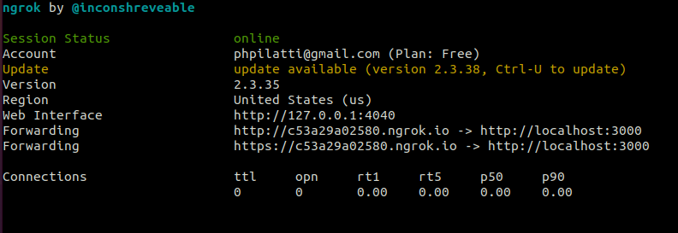

This URL can be accessed on any network.

3.2. Tunneling only HTTPS.



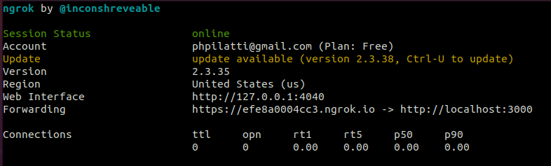

Only forward HTTPS traffic.

On the free plan, ngrok’s URLSs are randomly generated and temporary.